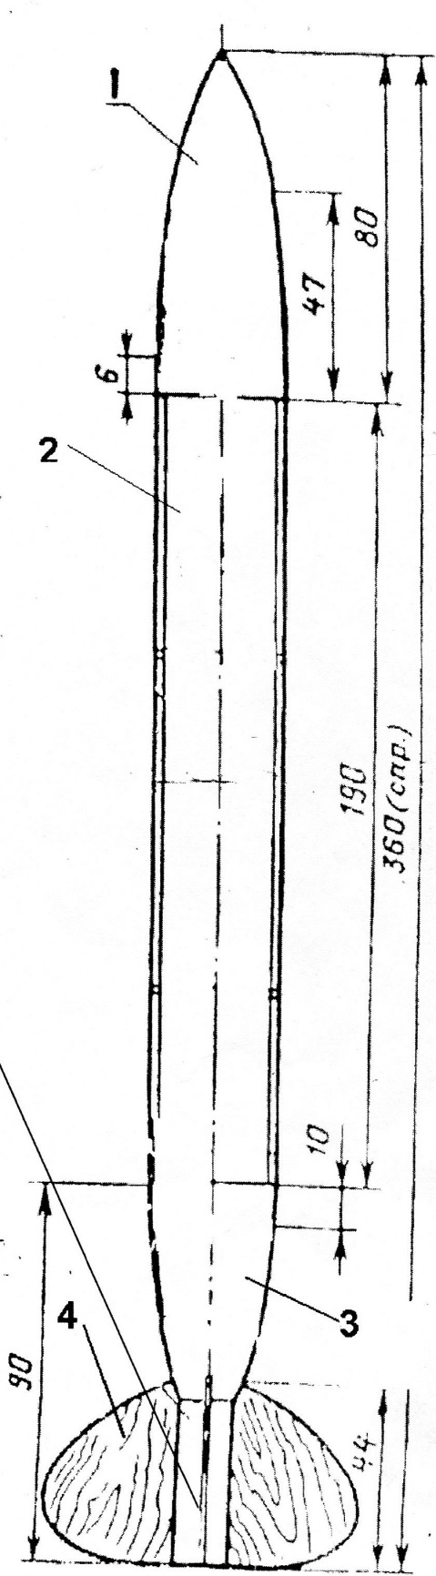**Rocket model class S-3-A**

For the beginners the mail material for modeling (to manufacture)a rocket is a paper. Stabilizers are made of phony veneer or corkwood.

You should start modeling with the rocket airframe, in simple models airframe better to be cylindrical.

All parts should be connected by Nitro glue kind of EMALIT or PVA (polyvinyl acetate).

3 stabilizers are cut according to the drawing.

The system of saving is a parachute or brake tapes.

Diameter of the dome is not more than 400-500 mm.

Rocket airframe and head fairing are connected by caprone thread.

The parts of the rocket:

1.Head fairing

2.Rocket airframe

3.Bottom of the airframe

4. Stabilizer

5. Engine room

